**WRITE UP**

**PROJECT: Implement Spring Security with Authentication**

**Project Description:**

* As a developer, build Authentication Provider in Spring Security.
* Create a maven project for security login

**Application Flow:**

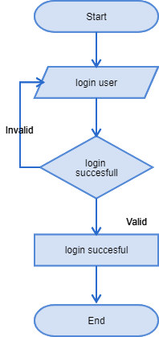

**Core concepts used in project:**

● Node.js  
● Jenkins  
● Angular Application

**Conclusion:**

This project is designed for Implement Spring Security with Authentication.